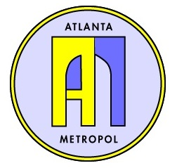
ATLANTA METROPOL
CHARITABLE GIVING REQUEST
DUE FEBRUARY 29, 2024

DUES PAID METROPOL MEMBER:
MEMBER’S ORGANIZATION:
MEMBER CONTACT NUMBER:
MEMBER’S EMAIL:

WHAT IS THE CHARITY AND ITS MISSION?

REQUESTED AMOUNT:

- Gifts are limited to $1,500
- Only one request per organization will be considered per calendar year
- The requesting organization must be an active participant in the charity
- Completed requests should be emailed to Rodney.Drinkard@coca-cola.com

